**Command Line Basics**

Before we get started with this section, it might be helpful to ensure we are all using the same shell configuration.

That said, here are some screenshots to show how your instructor has set up their shell:

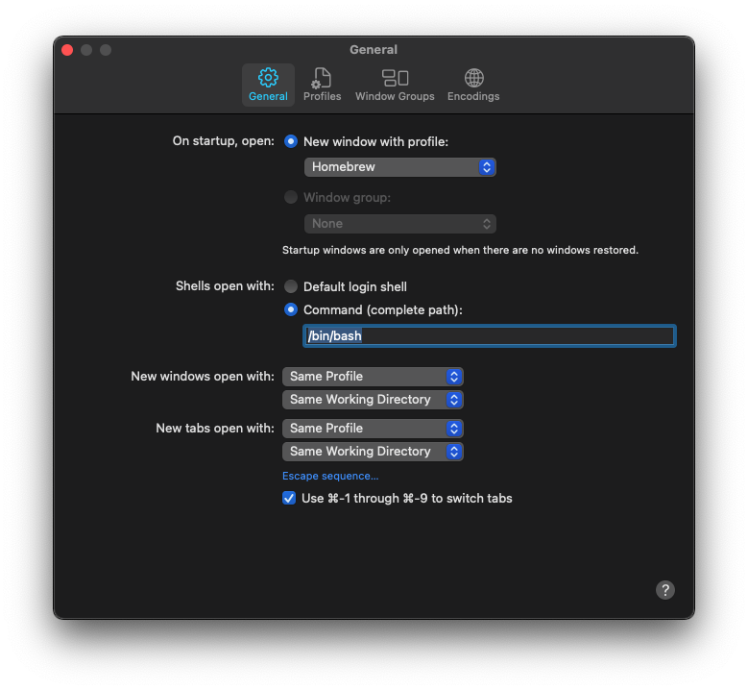 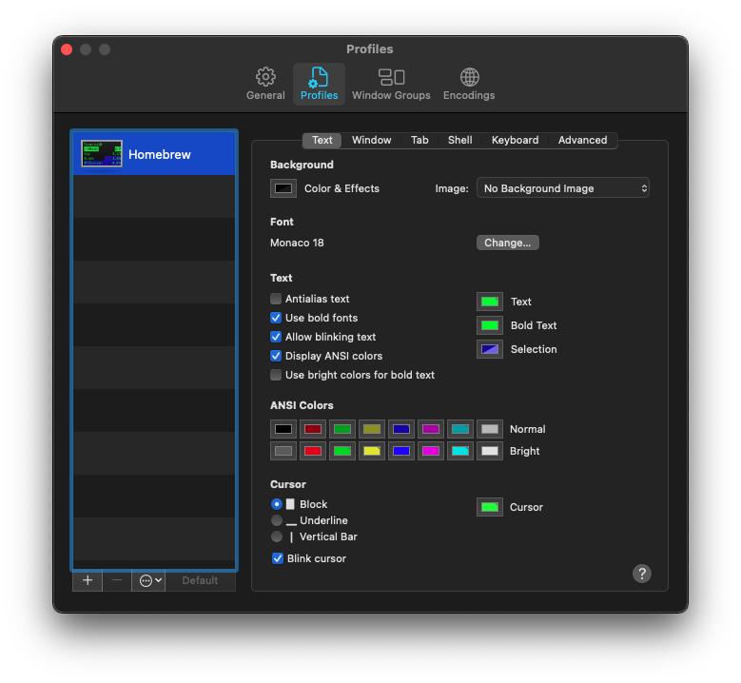 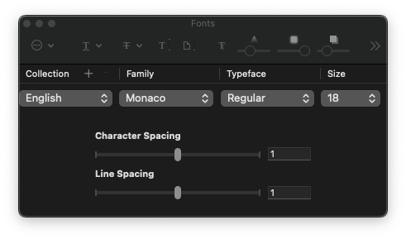

Now that we've reviewed shell config, here are the basic command tasks we'll try out:

* Change directories (folders)
* List a directory's contents
* Create a directory
* Create a file
* Move files and directories
* Copy files and directories
* Rename files and directories
* Delete files & directories
* Command history & clearing the window

**Change Directories**

* We use the cdcommand to change directories
* Let's change to the *home* directory of the logged in user:

$ cd ~

* Here are a few common shortcut characters used when navigating the filesystem:
  + ~The logged in user's *home* directory
  + /The *root* (top-level) directory on the harddrive
  + .The current directory
  + ..The parent directory of the current directory
* The pwdcommand "prints" the current (working) directory

**List a Directory's Contents**

* Use the lscommand to display a concise list
* lsdoes not display hidden files by default, adding the -aoption will show them
* treeis a nice utility for displaying a graphical representation of a directory and its nested directories.  
  Install it by typing brew install tree

**Create a Directory**

* Use the mkdircommand to create directories
* Let's create a drawersdirectory inside of the *home* directory:

$ mkdir ~/drawers

* Note that you don't have to specify the *full path* if we are already in the *home* directory

**Using Tab Auto-Completion**

* Change to the *home* directory
* Now let's change to our newly created drawersdirectory, however, only type cd d,  
  then press tabwhich will auto-complete directory name(s)
* You can cycle between matching directory names by continuing to press tab

**Creating Files**

* We use the touchcommand to create empty files
* Let's move to the drawersdirectory and create a directory named socks. Here is how we can create the directory **and** change to it using a single command:

$ mkdir socks && cd socks

* Now let's create a dress.socksfile:

$ touch dress.socks

**Practice Creating Directories and Files**

1. Create this directory: ~/drawers/pjs
2. Create two files in the new pjsfolder named warm.pjsand favorite.socks

**Moving Files**

* Okay, so we have a messy drawers/pjs, let's move our favorite.socksfile out of the pjsfolder and into the drawers/socksfolder where it belongs!
* Here's how we can do the move regardless of which directory we're currently in by using absolute paths:

$ mv ~/drawers/pjs/favorite.socks ~/drawers/socks/

Be sure to use tab-completion!

Note that you have the option to use *absolute* and/or *relative* paths.

**Moving Directories**

* Moving directories is just as easy using the same mvcommand
* Try it out:
  1. Create a ~/shortsdirectory
  2. Move the newly created shortsdirectory into the drawersdirectory

**Renaming Files**

* Guess what - there's no dedicated bash command to rename files and directories!
* Don't panic! The mvcommand is very flexible!
* Here's how we can rename the warm.pjsfile to summer.pjsfrom anywhere:

$ mv ~/drawers/pjs/warm.pjs ~/drawers/pjs/summer.pjs

* Of course, you can actually move and rename simultaneously!

**Deleting Files**

* We use the rmcommand to delete both files and directories
* Let's first use it to delete the dress.socksfile. Here's one way:

$ cd ~/drawers/socks && rm dress.socks

* Using the *wildcard character, it's possible to delete and move multiple files. For example, typing *.sockswould match all files with an extension of .socks...

**Deleting Directories**

* Deleting directories is almost the same as deleting files except you must use the -roption, which runs the rmcommand "recursively" to delete a directory and it's contents.
* To delete the pjsfolder we could use this command:

$ rm -r ~/drawers/pjs

**Moving Multiple Files**

* To demonstrate moving multiple files, re-create the dress.socksfile we just deleted from the socksdirectory
* Now let's move all of the .socksfiles out of the socksfolder into our *home* folder. The following command assumes we're inside the socksfolder:

$ mv *.socks ~

* Now, without changing directories, return the socks files back to where they belong

**Copying Files & Directories**

* Use the cpcommand to copy files and directories
* Here's how we can copy all **.js** files:

$ cp *.js ~/dest-folder

* And entire directories by adding the -Roption:

$ cp -R ./sample-code ~/dest-folder

**Command History & Clearing the Window**

* Pressing the up and down arrows in Hyper will cycle through previously entered commands. This can be a huge time saver!
* If you'd like to clear the Hyper window, simply press cmd+k